“An extraordinary volunteer experience”
Navitas AMEP English
Volunteer Tutor Training

You are invited to the Tutor Training series:
Conducted over 4 Tuesdays 5:00pm–9:00pm

Start: Tuesday 17th September 2019
End: Tuesday 8th October 2019

Location: Room Number 11
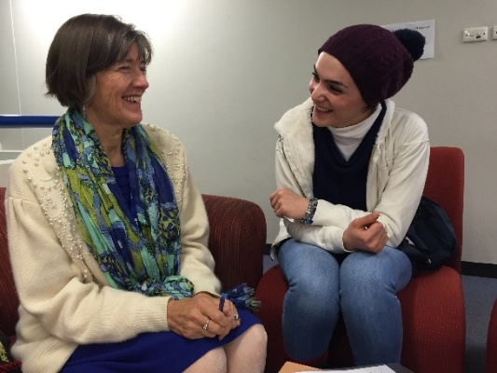
Level 2, 2 Jacobs Street
Bankstown 2200

(Afternoon tea is provided–please bring dinner)
NB: There is street parking (non-metered) further up Jacobs Street.

If you would like to help a new migrant or refugee
Join Navitas English AMEP as a Volunteer Tutor
- Interactive training workshops with a qualified teacher
- On successful completion, you will be paired with a person, settling into the Sydney community.
- The Volunteer Tutor Scheme provides you with ongoing support and resources.
- You will be providing one hour per week of English language tuition for an eligible adult migrant or refugee who cannot attend AMEP English classes.

Contact: Marcella Aguilar
Ph: 9707 0264
Email: Marcella.Aguilar@navitas.com

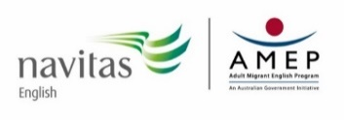
The Adult Migrant English Program (AMEP) provides eligible migrants and humanitarian entrants with up to 510 hours of free* English language learning and is funded by the Australian Government Department of Education and Training.

